**Multiple Choice Short Answer Total**

**/30**

**/20**

**/10**

**SECTION ONE: Multiple choice answers**

**Cross (X) through the correct answer.**

|  |  |  |  |  |
| --- | --- | --- | --- | --- |
| **1** | **a** | **b** | **XXX** | **d** |
| **2** | **a** | **b** | **XXX** | **d** |
| **3** | **a** | **b** | **XXX** | **d** |
| **4** | **XXX** | **b** | **c** | **d** |
| **5** | **XXX** | **b** | **c** | **d** |
| **6** | **XXX** | **b** | **c** | **d** |
| **7** | **a** | **b** | **c** | **XXX** |
| **8** | **a** | **b** | **XXX** | **d** |
| **9** | **XXX** | **b** | **c** | **d** |
| **10** | **a** | **XXX** | **c** | **d** |

**Part B: Short Answer (20 marks)**

11. List and describe **two** evidences that supports for evolution. (4 marks)

1 mark for each correct evidence eg. Fossil records, homologous structures etc  
1 mark for a suitable description

1. Match the vocabulary word with the proper definition. (3 marks)

**Terms**

Artificial selection Evolution Wallace Natural selection Darwin Fitness

**Definitions**

Evolution Change in species over time.

Darwin One of the first scientists to propose that species change over time.

Wallace Developed a theory of evolution at the same time as Darwin.

Fitness An organism’s relative ability to survive and produce fertile offspring.

Natural Selection The process by which evolution occurs.

Artificial Selection Selecting for plants and animals with useful traits.

0.5 marks each

1. Galapagos finches (birds) live on several different islands. Birds from different islands appear different and are known as separate species. It has been proven that all the birds from all the islands originated from the same species.

**Describe** the process of speciation. (What steps are involved?) (3 marks)

0.5 mark each for name of correct step only - Separation / Adaptation / Reproductive Isolation

1 full mark each for a correct description with or without the name

1. **Explain** why variation is necessary **before** natural selection can occur. (2 marks)

*In order for natural selection to work, why can’t all the individuals in a population look the same?*

1 mark – Differences allows few individuals to adapt

1 mark – enables survival of the few which their traits is passed on

1. In the diagram, there are pelvis and femur (leg) bones in a whale.

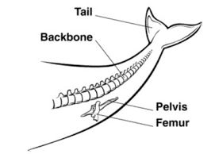

Describe how this is evidence for evolution (3 marks)

1 mark- stating Vestigial Structures

1 mark – suggests to be residual parts or unused parts from the past

1 mark – hence suggests a past/ common ancestor

1. Male peafowl, called peacocks, have long, colourful tail feathers. Among peacocks there is variation in the size, brightness, and pattern of the tail. Scientists observed the mating success of two groups of peacocks. The graph below shows the scientists’ data.

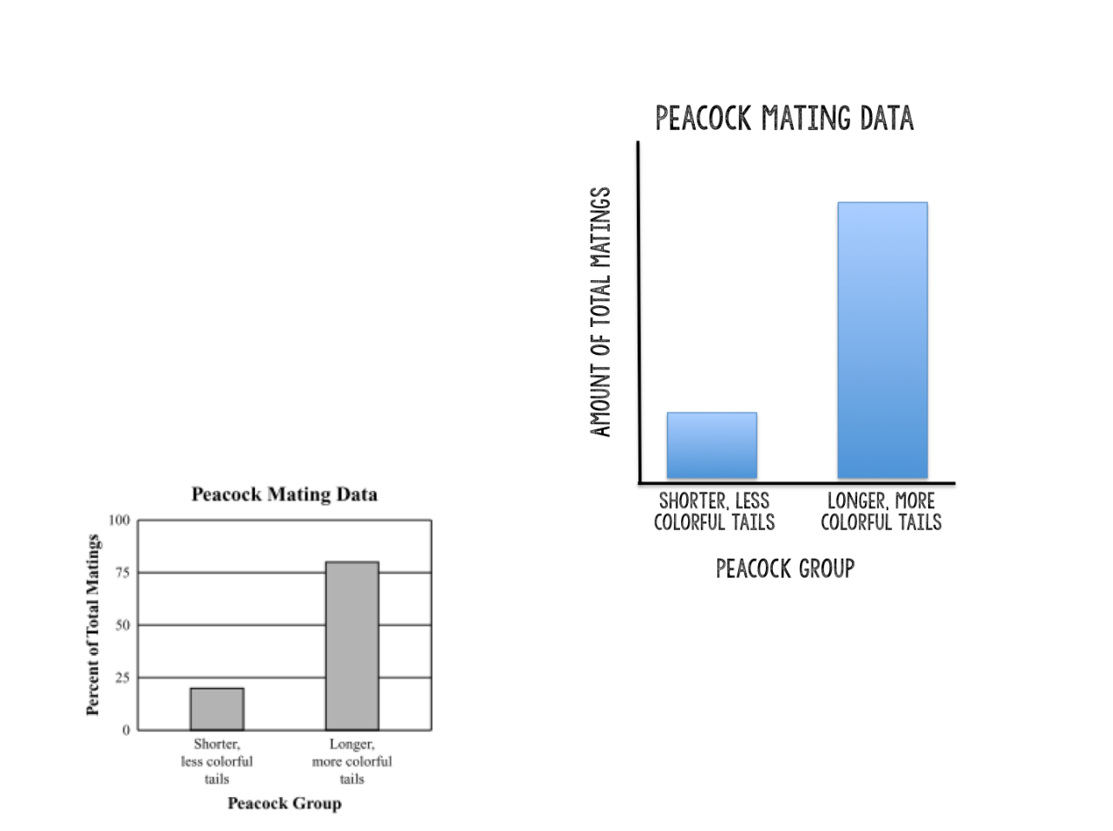

* 1. **Explain** what the graph shows about the advantage of longer, more colourful tails for peacocks (1 mark)

**The advantage is that they have an increased amount of total matings**

* 1. Identify **one** disadvantage that longer, more colourful tails may have for peacock.

(1 mark)

**Those with longer, more colourful tails are more easily seen by predators**

1. A forest has many trees and bushes that produce nuts. This is a major food source for many species, include a particular bird. Birds of this species have a variety in beak shapes ranging from long and pointy to short and hard. The birds with short and hard beaks are able to eat the nuts better than the birds with long and pointy beaks.

What do you expect to happen to this population of birds over time, in terms of what you know about evolution? Address all the principles of natural selection in your explanation. (3 marks)

1 mark – short beaks will be more frequent in population

1 mark – short beak birds have more access to food hence live longer hence reproduce more

1 mark – hence the short beaks trait gets passed on to the offspring